Packet Tracer Assignment 3 - VLSM – 10 MARKS (worth 10%)

Objective: To familiarize yourself with subnetting using VLSM, static routing, EIGRP, and OSPF

* Please submit hard copy. Refer to SLATE calendar for due date.

Name: ________________________

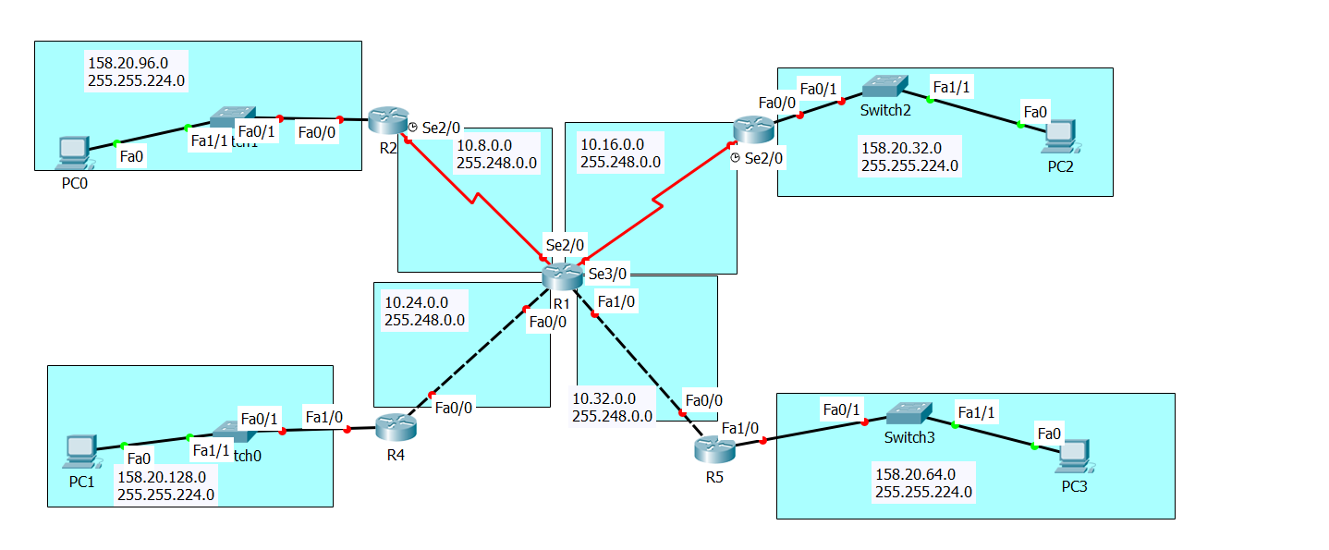

Part 4: Writing the configuration commands [10 marks]

* Complete the following commands in the spaces provided. Marks are indicated.
* Do not write the prompts. Just write the commands. You may write them in pencil.

|  |  |
| --- | --- |
| Configure R4 with router RIP  [1] | R4#  Config t  Router rip  Version 2  Network |
| Configure R1 with static routing.  [4] | R1# |
| Configure R5 router with static routing.  [1] | R5# |
| Configure R3 with EIGRP  - Use A.S. #20  [2] | R3# |
| Configure R2 router with OSPF   * Use Area 0 * Use process ID 10   [2] | R2# |